National University of Technology


Computer Science Department
Course: Software Engineering
Semester Fall – 2024
Assignment – 1

Submitted To: Submitted By:
Mam Afia Zafar Muhammad Zaheer F23605043
Department CS 23-A Muhamad Moazzan F23605016

The topic we selected is
Credit Card Fraud Detection System

Description:
A system designed to detect and prevent fraudulent transactions by analyzing patterns in credit card usage. It helps identify suspicious activities in real-time and protects both businesses and consumers from financial fraud.

Key Features:
- Real-time transaction monitoring.
- Anomaly detection using machine learning algorithms.
- Fraud pattern analysis.
- Automatic alerts for suspicious transactions.
- Dashboard for reviewing flagged transactions.

Technology Stack:
- Frontend: React or Angular for dashboard interfaces.
- Backend: Python (for machine learning), Node.js for API integration.
- Database: MySQL, MongoDB for storing transaction data.
- Machine Learning: Scikit-learn, TensorFlow for fraud detection models.
- Deployment: AWS, Docker for cloud hosting and containerization.

Target Audience:
- Financial institutions (banks, credit unions).
- E-commerce platforms.
- Credit cardholders.

Expected Outcomes:
- Reduce financial losses due to fraud.
- Improve security of credit card transactions.
- Minimize false positives in fraud detection.
- Team Members: List of group members with their respective roles (e.g., frontend developer, backend developer, data scientist).

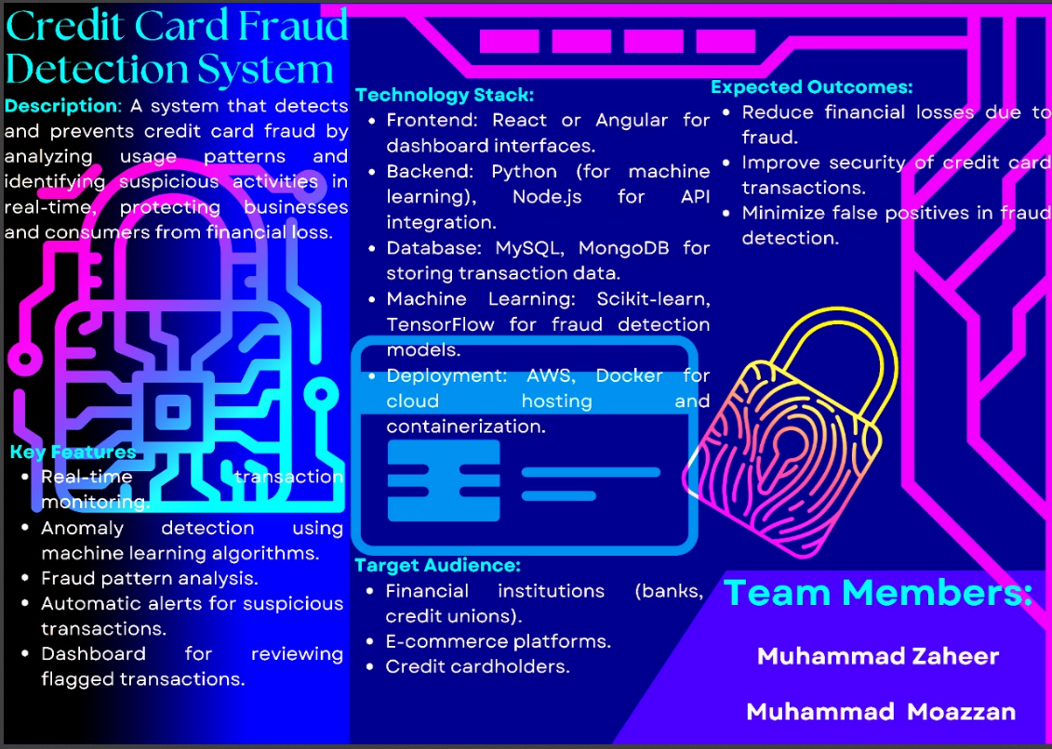

Flowchart description
- The credit card transaction is initiated.
- Input: Transaction details are collected (e.g., amount, location, cardholder information).
- Process: The system analyzes the transaction using machine learning models.
- Check against normal spending patterns.
- Compare with past transactions.
- Decision: Is the transaction potentially fraudulent?
  - If yes. Alert is triggered, transaction flagged for review.
  - If no. Transaction is processed normally.
- The transaction is either approved or flagged.
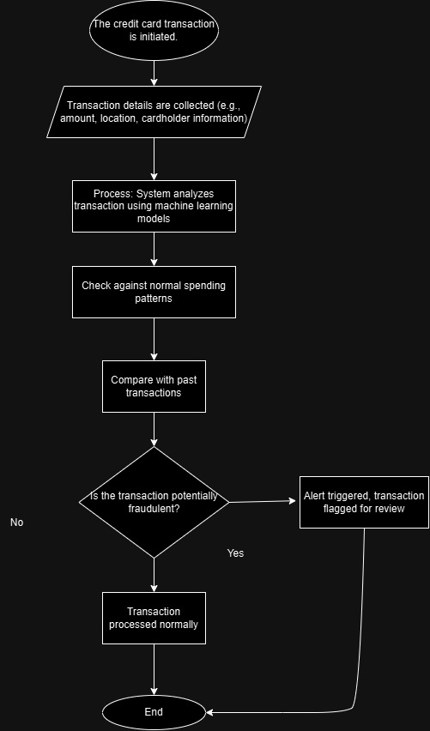
Gantt Chart description
- Planning (Week 1-2): Research and select algorithms, define requirements.
- Design (Week 3-4): Create system architecture, data flow diagrams.
- Development (Week 5-10):
- Build backend with machine learning models.
- Design frontend dashboard.
- Integrate APIs for real-time transaction monitoring.
- Testing (Week 11-12): Run tests on the model, ensure accuracy in fraud detection, refine algorithms.
- Final Review and Submission (Week 13): Complete the project, polish documentation, and submit.
